# PLC Lab 5: HMI Applications

## Objectives

* Configure HMI hardware to work with PLC
* Program HMI applications
* Program HMI applications - Analog values

## Tasks

* Task 1: Configure HMI to work with PLC
* Task 2: Programming HMI Buttons and LEDs
* Task 3: Programming HMI – Analog Values
* Task 4: Programming HMI Applications (DIY)

## Synopsis

HMI stands for Human Machine Interface, and typically refers to touch screens which allows users to interact with machines. Users can see the status of the machine through graphical display and can also send instructions to the machine through pressing of a virtual button or entering a number using a keypad.

## Equipment Required

* PLC training kit with control panel and HMI.
* Laptop/PC with internet access
* Laptop/PC installed with TIA Portal V15.1 and PLCSIM

## Reference and Self Study materials

* Lab 05 Videos   
  <https://www.youtube.com/playlist?list=PLo5IISMe0m5P6ogB9Hp7H4QeHQV32sMac>
* TIA Portal help files (Access from TIA Portal)

## Task 1: Configure HMI to work with PLC

Watch the video to see how to configure your HMI to work with the PLC   
(Video’s firmware **V15.0.0.1 had been updated to V15.1.0.0**)

<https://youtu.be/VDw-piXIQB4>

Open the PLC Template file. Add new device and select the following item.

|  |  |  |  |
| --- | --- | --- | --- |
| Device Type | Article Number | Firmware | Configure IP |
| TP700 Comfort | 6AV2 124-0GC01-0AX0 | 15.**1.0.0** | 192.168.0.5 |

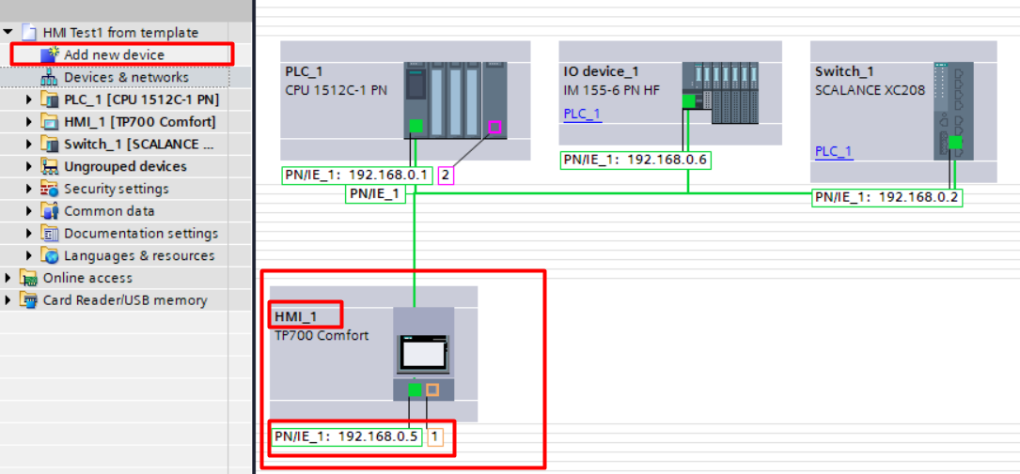

**192.168.0.4**

## Task 2: Programming HMI Buttons and LEDs



Create a simple ladder program to show the ease of interface to HMI. %I %Q and %M tags can all appear on the HMI screen. Note that %I is a physical input and cannot be modified by the HMI. So we have created a HMI_Button1 using global memory %M.

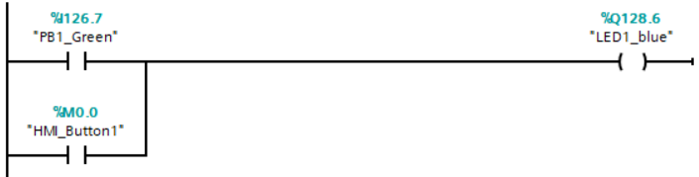

Add a new screen. Define the new screen as a start screen. Add in circles and text from Basic objects menu. Add in Buttons from Elements menu.

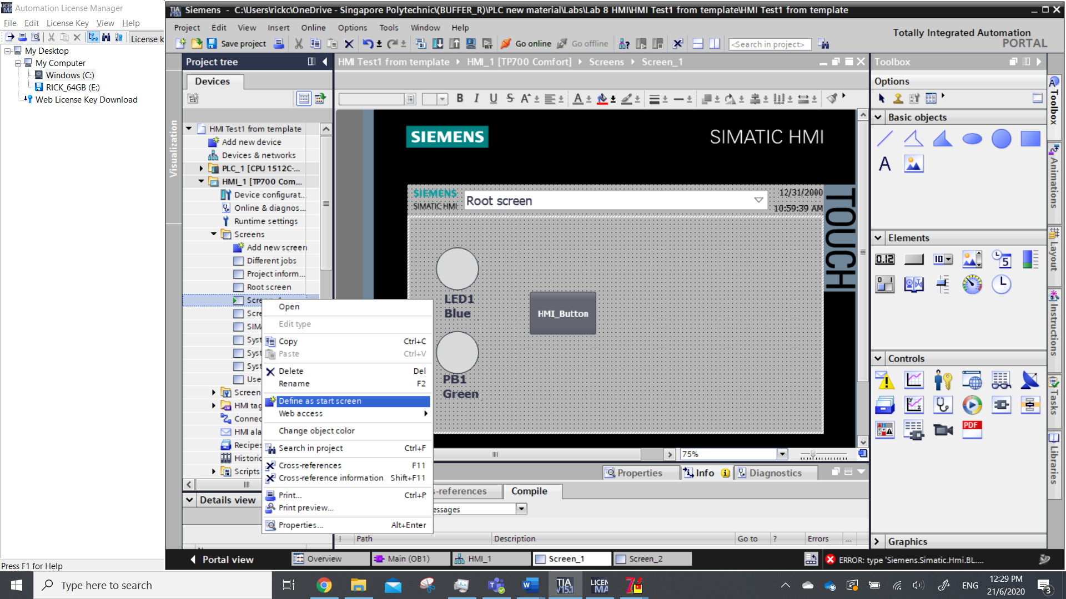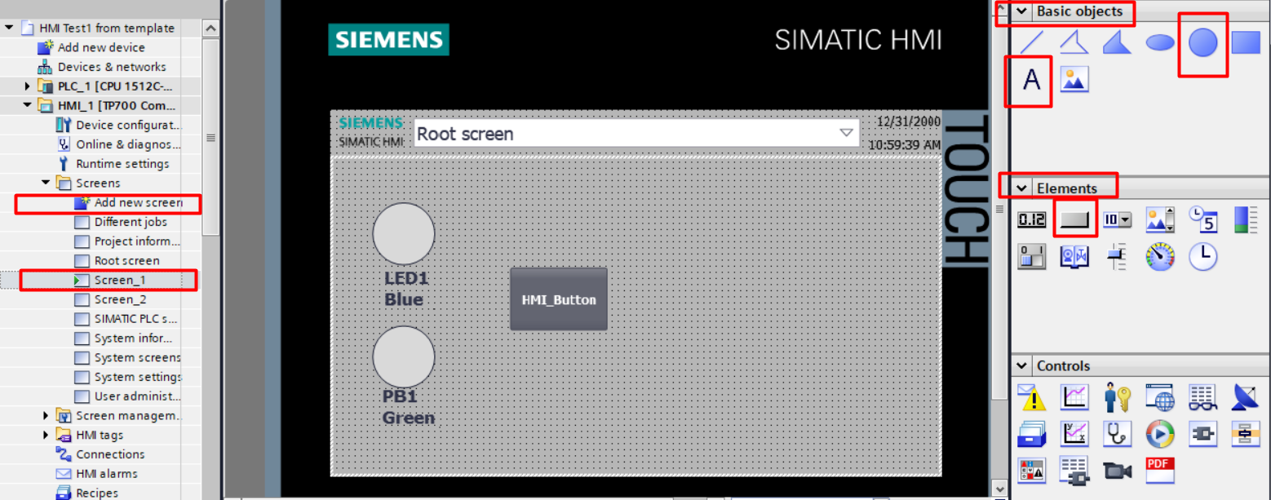

To link the circle to a valid PLC Tag, click on the circle, Properties>Animation>Add new animation>Appearance. Browse for tag under PLC default tag table, link it to the desired tag. In this case, we link the circle to LED1_blue %Q128.6. You can choose the color that shows up when the LED is off ‘0’ or on ‘1’.

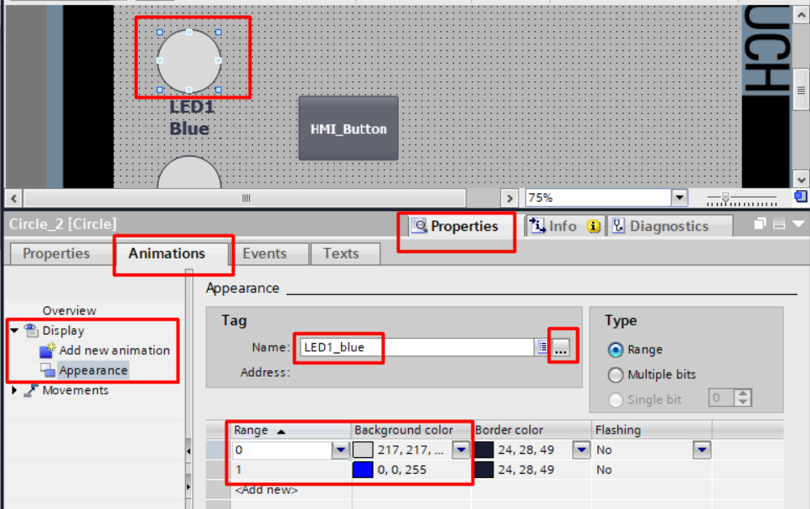

To create a button that can be pressed on the HMI screen, click on the button, select Properties>Events>Press>SetBit. For the tag, browse to PLC default tag table to select HMI_Button1. Repeat the process for Release>ResetBit,

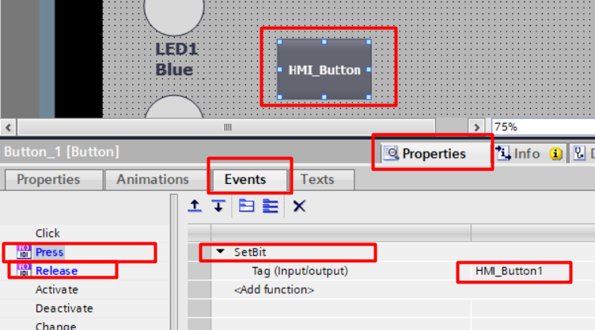

Perform a download for PLC followed by a separate download for HMI. It is important to know that they are separate device running different programs although the programming environment is the same in TIA Portal. (We are downloading to real physical devices, but if you do not have access to physical devices, it is also possible to run both PLC/HMI in simulation by clicking start simulation for both devices)

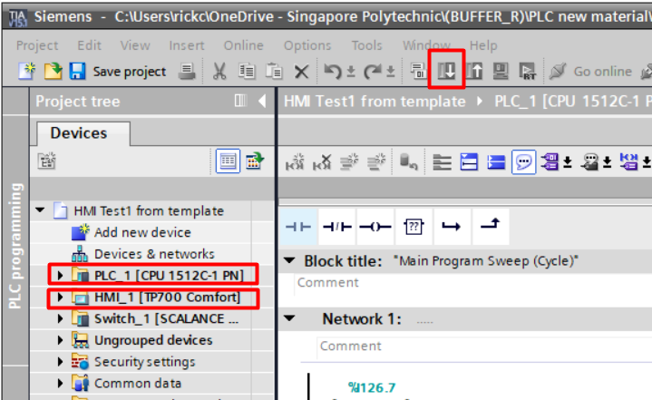

## Task 3: Programming HMI – Analog Values



Watch this video to see how to program HMI with analog values <https://youtu.be/fXBg57jIhQ8>

Create a program to show the use of analog values. The use of positive edge is so “Number” only increment or decrement by 1 regardless how long the HMI button is pressed. Get the INC and DEC instructions from Math functions.

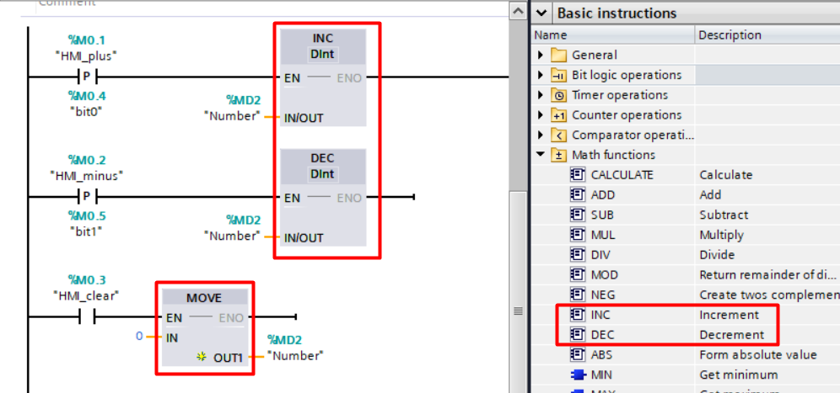

The integer value “Number” can be added to the screen in a variety of way below, such a numerical display, a gauge, and a slider bar. The real physical input potentiometer %IW128 can also be displayed. (remember to create the potentiometer tag in the PLC default tag table and download to the PLC)

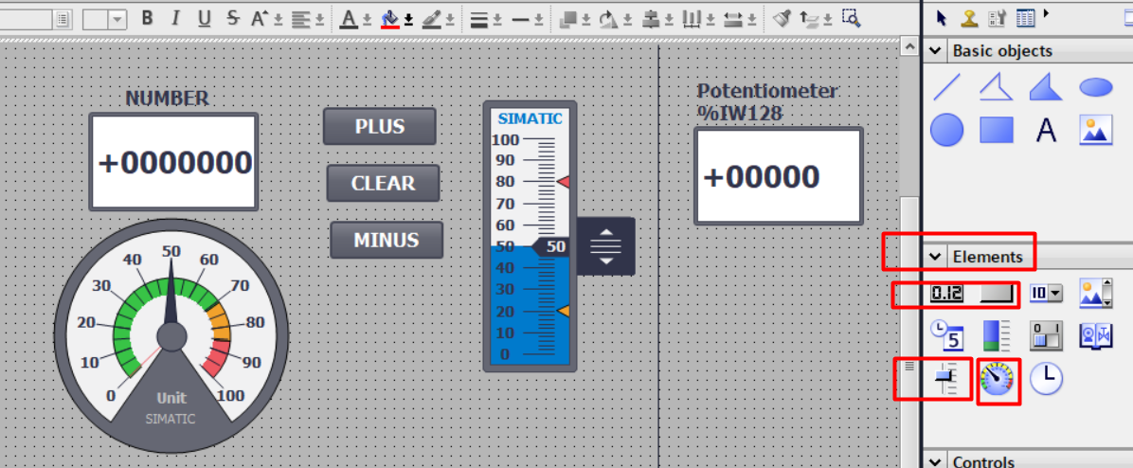

For each the analog elements below, the steps to link to the variable “Number” is the same. Select the element, click Properties>Animations>Tag connections>Add new animation>Connect tag to property. Link to “Number” in the PLC default tag table

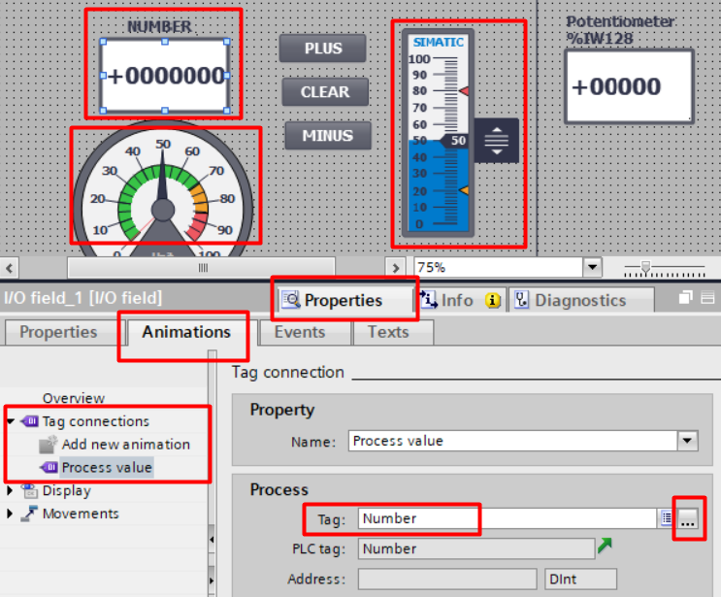

Download and test your program.

## Task 4: Programming HMI Applications (DIY)





View the task requirements <https://youtu.be/EVQwqtWHE1Q>

This has been programmed and You need to create this HMI

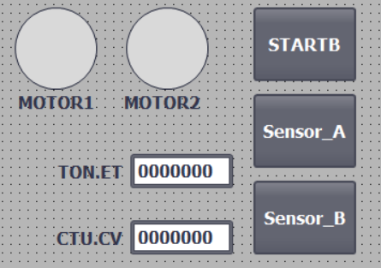given to you.

SensorB **count 3 times**

INIT

S1

S2

Turn on Motor1

STARTB

S3

Turn On Motor2/Motor1  
M

**8 seconds** or SensorA

S4

Turn off both Motors

‘1’ or TRUE

You need to map these tags in the HMI

|  |  |
| --- | --- |
| Tag | Address |
| startb | %M1.2 |
| sensorA | %M1.3 |
| sensorB | %M1.4 |
| Motor1 | %Q128.6 |
| Motor2 | %Q128.5 |
| CTU1.CV | Available from Program blocks>system blocks>program resources |
| TON.ET |  |

CTU1.CV and TON.ET is not in PLC default tag table, but they can be located as follows

